**EDGE: BU-CSE Digital Skills Training**

**  **

# **A Project On**

"S. Alam Cold Rolled Steel Financial Statement Analysis & Valuation"

**Submitted by:**

Mst.Shaudia Islam

Roll: 09

Batch: 59

**Date of submission:**

**Table Of Content**

|  |  |  |
| --- | --- | --- |
| No | Contents | Page No |
|  | **Introduction** | 07-13 |
| 1 | Introduction to The Report | 07 |
| 2 | Objective of The Study | 08 |
| 3 | Methodology | 09 |
| 4 | Industry Overview | 10- 13 |
| 5 | Company Overview |  |
|  |  |  |
|  | **Financial Statement Analysis** | 16-20 |
| 6 | Income Statement | 17 |
| 7 | Common Sized Income Statement | 18 |
| 8 | Financial Position Statement | 19 |
| 9 | Common Sized Financial Position Statement | 20 |
|  |  |  |
|  | **Du-Pont Analysis** |  |
| 10 | Three Factor | 21 |
| 11 | Five Factor | 21 |
|  |  |  |
|  | **Ratio Analysis** |  |
| 12 | Ratio Calculation | 22 |
| 13 | Analysis of Ratios | 23-25 |
|  |  |  |
|  | **Free Cash Flow Valuation** | 26 |
|  | **Relative Valuation** | 27-29 |
|  | **Conclusion** | 30 |
|  | **References** | 31 |

**Introduction**

**Introduction to The Report**

S. Alam Cold Rolled Steel Company Limited is a company that has always tried to provide the best possible products for its customers since 2001. It focusses on producing reinforced steel, deformed bars using updated technology while ensuring proper weight distribution so anyone get what they are looking for no matter how complicated it may seem. This report mainly focused on the financial statement analysis and valuation of the company using various mathematical tools. With the report the investor will be able to get an overview of the financial performance of the company and they will also be able to take their investment decisions considering the forecasted share price whether it is under price or over price.

**Objective of The Study**

Main objective of the study of S. Alam Cold Rolled Steel limited are identified as follows;

* To learn about the financial summary of the company’s operating result during the selected period.
* To learn about the financial position of the company during the selected period.
* To study about the common size financial summary of the company for the selected period.
* To study about the common size financial position of the company for the selected period.
* To analyze the relevant ratio of the company for the selected period.
* To analyze the du point of the company for the selected period.
* To forecast the relevant information of the company for the following years.
* To forecast the firm value and share price for the company for the selected year.
* To make the comparison of the company with the industry benchmark to identify the efficiency of the company.

**Methodology**

Methodology refers to the technique through which the study is conducted. I have taken the relevant data form the financial statement of S. Alam Cold Rolled Steel Limited and then prepare the income statement and balance sheet for the company which help me to prepare the common size income statement and balance sheet. With the published information, I have calculated the relevant ratios of the company. Those ratios help me a lot to make the du point analysis of the company. To forecast various data of the company I depends on the relevant hypothesis and with the rational hypothetical data I have forecasted the firm value and stock price of the company.

**An Overview of Steel Re-Rolling Industry in Bangladesh**

The steel re-rolling sector in Bangladesh has evolved into a strategic driver of the nation's economic growth, playing a vital role in shaping the country's overall infrastructure. Concentrated primarily in the bustling city of Chittagong, this industry has transcended its early stages to become a pivotal contributor to various sectors, including transportation, energy, heavy engineering, and construction. By providing crucial steel products such as rebar, angles, and beams, the industry has emerged as a linchpin of Bangladesh's transformative journey.

Emerging trends within the sector illuminate the strategic emphasis on branding and promotion. BSRM's pioneering move to launch promotional campaigns across various media platforms set a precedent that others have subsequently followed. Furthermore, consumer consciousness has elevated, with purchasers now prioritizing a nuanced understanding of the steel's type and grade. This heightened awareness ensures that purchasing decisions are rooted in informed choices.

Additionally, the industry's prowess extends to international arenas through escalated exports. As local demand for steel escalates, surplus production is being channeled for export, marking an impressive trajectory of growth. Responding to this amplified dynamic, domestic steel producers are capitalizing on the situation by expanding their production capacities, ensuring a substantial contribution to both local and global needs.

Notwithstanding these optimistic projections, the industry grapples with its fair share of challenges. A reliance on imported raw materials remains a persistent obstacle, necessitating vigilant supply chain management to mitigate disruptions. Furthermore, the unpredictable timelines of mega projects pose a considerable challenge, potentially derailing production forecasts and undermining industry stability. Inconsistencies in governmental policies and regulations, encompassing tax reforms and fluctuating interest rates, present an additional layer of complexity.

Despite these trials, the industry's potential for growth is underscored by a multitude of opportunities. The possible discovery of an iron ore reserve in Dinajpur could revolutionize the industry's raw material sourcing, minimizing dependence on imports. Concurrently, proposed developments in port facilities hold the promise of streamlining scrap steel imports, thereby augmenting production capacities.

To sustain this upward trajectory, the industry must lay emphasis on augmenting domestic production, enhancing research and development initiatives, and optimizing labor force utilization. The assurance of a secure and conducive work environment for the industry's labor pool remains an essential priority.

There are around 400 steel mills in Bangladesh with a total production capacity of around 8 million MT. Currently major steel producers Abul Khair and BSRM plan on significantly raising their crude steel production. KSRM, GPH, Anwar, Rani, and SSRM are also expanding. According to a 2016 report by EBL, Abul Khair, BSRM, and KSRM account for more than 90% of total capacity in manufacturing billet, and more than 50% of country’s’ annual demand.

The demand for steel in is mainly driven by infrastructure projects in commercial, housing, and the public sector can be further broken down to implementation of the governments annual development plans and infrastructure projects. It's estimated that the sector turns over around 3.6bn every year. In 2016, government projects amounted for almost of total steel consumption. Bangladesh is heavily reliant on imports of semi-finished and steel products as well as flat products while being strategically next to the top two steel producers in the world, China and India. The majority of imports are scraps, flat products, and semi-finished and finished steel products making up a total of 6.992 million MT or over 93% Of all imports.

Bangladesh steel industry has experienced around 10% to 15% growth per annum leading to total demand of 7.5 million MT in the last fiscal year. The country is also one of the largest importers of Scrap, Sponge and Pig iron – understood to be 2nd largest scrap importer in South East Asia and 4th in as a whole Asia region.

**STEEL INDUSTRY AT A GLANCE**

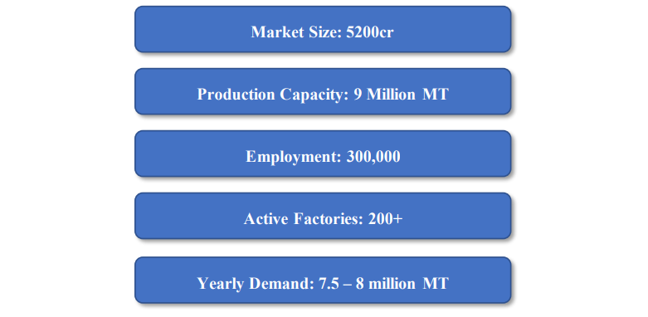

**CURRENT STEEL PRODUCTION CAPACITY IN BANGLADESH (UNITS IN LAC METRIC TONS)**

**DEMAND OF STEEL IN BANGLADESH**

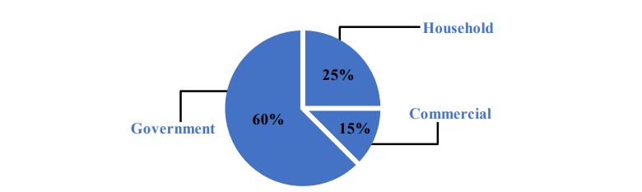

There were 60 percent of steel used in Bangladesh’s public sector, 25 percent of steel used in households, and 15 percent used in commercial construction. Demand for steel in Bangladesh is growing rapidly. Even a decade ago, the demand was 1.6 million metric tons, but it reached 7 million tons in 2018, and is expected to rise to 18 million tons by 2030.

The global steel industry is going through a slowdown; however, there are a few countries which have extremely well and Bangladesh is one of them. The steel sector in Bangladesh has recorded a 15 per cent growth in 2015 riding on infrastructure projects both housing and public utilities. The country is one of Asia's most emerging steel markets and has a growing need for raw materials and steelmaking technologies.

The ongoing major projects like Bridget 'Dhaka- Chittagong Access Control Highway' and the upcoming major projects like 'Dhaka Elevated Expressway' and the “Deep Sea Port” would be requiring huge quantity of quality construction materials. Historical data shows that consumption of steel has been increasing. The industry grew from producing a merge MT in 1971 to 4.0 million Mt in 2016.The production of this sector expected to double about 8.0 million Mt on 2022 by the industrialists. (Steel industry review, 2018). Iron Scrap is a major raw material for steel units based in Bangladesh. Only a small number of small materials are available from local source and the country needs to import significant volume of iron scrap materials from abroad. The import of iron scrap has increased significantly over the last few years. Increasing trend of the importing indicates future growth of the industry.

In summation, the steel re-rolling industry in Bangladesh stands as a testament to the nation's determination to forge its economic path. From modest beginnings in the 1950s to its present-day significance, the sector's evolution mirrors the broader narrative of resilience and adaptability. As it navigates challenges and seizes opportunities aligned with mega projects, the industry is poised for a continued era of expansion, significantly contributing to Bangladesh's metamorphosis into a thriving economic powerhouse.

**COMPANY OVERVIEW**

S. Alam Cold Rolled Steels Limited is the‑agship company of the S. Alam Group, a well-established business conglomerate in the country, operating in the business of steel manufacturing. It was incorporated on December 12, 2000 as a Public Limited Company vide certificate No. 3842 of 2000 under the Companies Act 1994. The registered ace of the company is located at S. Alam Bhaban, 2119 Asadgonj, Chattogram, while the factory is situated at Kalarpool, Shimabara, Patina, Chattogram. The company has been set up to manufacture C.R. Steel Strip in the coils/sheets with 6-HI, CVC reserving cold rolling mill having an installed capacity of 120,000 MT per annum, and started its commercial operation on February 16, 2004. Afterward, in order to meet the increasing demand for non-oxide furnace (NOF) type GP/CI sheets throughout the world and in this region, S. Alam Cold Rolled Steels Limited set up a NOF type continuous galvanizing line (CGL) with a CTL plant for production of GP/CI sheets with the most modern and economical technology using the C.R. Coils produced by the company. The annual installed capacity of the NOF Plant is 72,000 M. Ton.

The company is pioneer in steel industry and well known for its galvanized plain sheet and galvanized corrugated iron sheet which are mainly used in construction industry (Rong and cladding of houses and industrial sheets), agriculture and outdoor application also.

The Authorized Capital of the Company is Taka 350,00,00,000 divided into 35,00,00,000 ordinary shares of Tk. 10/- each. Paid up capital of the company is Taka 98,37,11,000 divided into 9,83,71,100 ordinary shares of Tk. 10/- each.

With a view to maximizing shareholders bennet and ensure uninterrupted electric supply, the company established its subsidiary- S. Alam Power Generation Limited having 17MW Capacity power plant which was incorporated as a private limited company on April 09, 2009 with 70% of its Equity held by this company. The objectives among others to set up, operate and run a captive and/or independent power plant to produce and supply electricity.

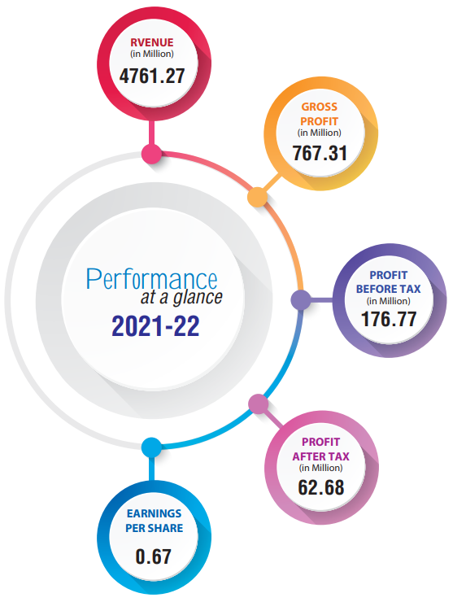**Performance of S. Alam Company**

**Mission of S. Alam Cold Rolled Company**

**INCOME STATEMENT**

|  |  |  |  |  |  |
| --- | --- | --- | --- | --- | --- |
| **S. Alam Steel Ltd. Income Statement From 2018 to 2022** | | | | | |
|  |
|  |
| **PARTICULARS** | **2022** | **2021** | **2020** | **2019** | **2018** |  |
| **Revenue** | 4761.27 | 5,348.22 | 4,085.00 | 5,170.82 | 3,806.74 |  |
| **Cost of Sales** | 3993.96 | 4,602.98 | 3,454.92 | 4,365.05 | 3,224.83 |  |
| **Gross Profit** | 767.31 | 745.24 | 630.07 | 805.76 | 581.92 |  |
| **Selling and Distribution  Expenses** | 0.84 | 0.34 | 2.16 | 0.53 | 0.86 |  |
| **Administrative Expenses** | 49.14 | 56.81 | 48.19 | 52.14 | 58.58 |  |
| **Operating Profit** | 717.33 | 688.08 | 579.71 | 753.08 | 522.47 |  |
| **Financial Expenses** | 539.03 | 508.94 | 459.2 | 408.14 | 345.06 |  |
| **Profit before  Non-operating Income** | 1256.36 | 1197.02 | 1038.91 | 1161.22 | 867.53 |  |
| **Other Income** | 0 | 0 | 0 | 0 | 0 |  |
| **Finance Income** | 8.34 | 6.47 | 7.51 | 8.59 | 8.08 |  |
| **Contribution to WPPF  and Welfare Fund** | 9.91 | 9.99 | 6.75 | 18.23 | 9.69 |  |
| **Profit before Tax** | 1274.61 | 1213.48 | 1053.17 | 1188.04 | 885.3 |  |
| **Income Tax Expenses** | 114.05 | 93.3 | 69.75 | 235 | 55.07 |  |
| **Total Comprehensive  Income** | **1388.66** | **1306.78** | **1122.92** | **1423.04** | **940.37** |  |

**COMMON SIZED INCOME STATEMENT & TREND ANALYSIS**

|  |  |  |  |  |  |
| --- | --- | --- | --- | --- | --- |
| **Common Sized Income Statement & Trend Analysis  From 2018 to 2022** | | | | | |
|  |
|  |
| **Particulars** | **2022** | **2021** | **2020** | **2019** | **2018** |  |
| **Cost of Sales** | **84%** | **86%** | **85%** | **84%** | **85%** |  |
| **Gross Profit** | **16%** | **14%** | **15%** | **16%** | **15%** |  |
| **Operating Profit** | **15%** | **13%** | **14%** | **15%** | **14%** |  |
| **Net Income before Tax** | **4%** | **3%** | **3%** | **6%** | **5%** |  |
| **Total Comprehensive Income** | **1%** | **2%** | **1%** | **2%** | **3%** |  |

**FINANCIAL POSITION STATEMENT**

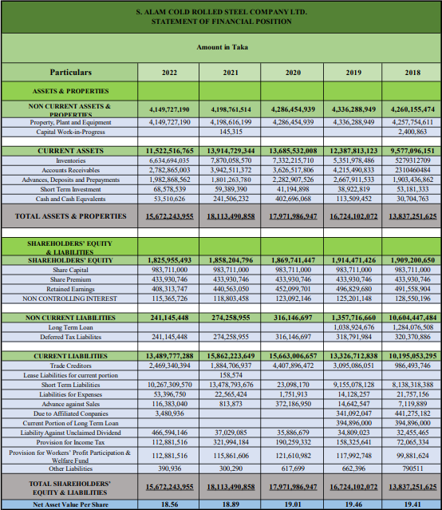

**COMMON SIZED FINANCIAL POSITION STATEMENT & TREND ANALYSIS**

|  |  |  |  |  |  |
| --- | --- | --- | --- | --- | --- |
| **S. ALAM COLD ROLLED STEEL COMPANY LTD. COMMON SIZED STATEMENT OF FINANCIAL POSITION** | | | | | |
|  |
|  |
| **Particulars** | **2022** | **2021** | **2020** | **2019** | **2018** |  |
| **TOTAL ASSETS** |  |  |  |  |  |  |
| **CURRENT ASSETS** | **74%** | **77%** | **76%** | **74%** | **69%** |  |
| **NON-CURRENT ASSETS & PROPERTIES** | **26%** | **23%** | **24%** | **26%** | **31%** |  |
| **TOTAL ASSETS &  PROPERTIES** | **100%** | **100%** | **100%** | **100%** | **100%** |  |
| **SHAREHOLDERS’ EQUITY & LIABILITIES** |  |  |  |  |  |  |
| **CURRENT LIABILITIES** | **86%** | **88%** | **87%** | **80%** | **74%** |  |
| **NON-CURRENT LIABILITIES** | **2%** | **2%** | **3%** | **8%** | **12%** |  |
| **SHAREHOLDERS’ EQUITY** | **12%** | **10%** | **10%** | **12%** | **14%** |  |
| **TOTAL SHAREHOLDER'S EQUITY  & LIABILITIES** | **100%** | **100%** | **100%** | **100%** | **100%** |  |

**DUPONT ANALYSIS**

DuPont analysis (also known as the DuPont identity, DuPont equation, DuPont Model or the DuPont method) is an expression which breaks ROE (Return on Equity) into three parts.

|  |
| --- |
| **S. ALAM Cold Rolled Steel LTD.** |
| **Du Pont Analysis** |

|  |  |  |  |  |  |
| --- | --- | --- | --- | --- | --- |
| **Steps** | **2022** | **2021** | **2020** | **2019** | **2018** |
| **Decomposition of ROE (3 step)** | **8%** | **20%** | **10%** | **18%** | **21%** |
| **Decomposition of ROE (5 step)** | **8%** | **20%** | **10%** | **18%** | **21%** |

**RATIO ANALYSIS OF S. ALAM STEEL LTD.**

Ratio analysis compares line-item data from a company's financial statements to reveal insights regarding profitability, liquidity, operational efficiency, and solvency. Ratio analysis can mark how a company is performing over time, while comparing a company to another within the same industry or sector. Ratio analysis may also be required by external parties that set benchmarks often tied to risk. While ratios offer useful insight into a company, they should be paired with other metrics, to obtain a broader picture of a company's financial health.

|  |
| --- |
|  |
|  |
| **Liquidity Ratio Analysis**   * **Current ratio analysis for the year 2022-2018:**   **Interpretation:** The current ratio for the year, 2022, 2021, 2020, 2019 & 2018 are 0.86, 0.88. 0.87. 0.93 & 0.93 respectively, compared to standard ratio 2:1 this ratio is lower in the year 2022-2018. Which shows low short-term liquidity efficiency. As we know the higher the ratio, the more capable the company is of paying its obligations. A ratio under current ratio suggests that the company would be unable to pay off its obligations if they came due at that point. The company position is not good.   * **Acid test ratio analysis for the year 2022-2018:**   **Interpretation:** The Acid test ratio for the year,2022 2021, 2020, 2019 & 2018 are 0.37, 0.39, 0.40, 0.53 & 0.42 respectively, compared to standard ratio 1.1 this ratio is generally fall below in the year 2022-2018.The benchmark as we know for this ratio is 1, the trend of acid test ratio of S. Alam steel shows that the ratio had been decreasing. So, we can conclude here that the position of the company to assess and improve its short-term liquidity position. |
|  |
|  |
| **Activity Ratio Analysis** |
| * **Inventory Turnover ratio analysis for the year 2022-2018:**   **Interpretation:** The Inventory Turnoverratio for the year,2022 2021, 2020, 2019 & 2018 are 2.00, 2.00, 2.07. 2.63 & 2.27respectively, compared to standard ratio 5:10 this ratio is higher in the year 2022-2018. Overall this trends suggest that S. Alam took steps to enhance inventory management after 2018, achieving remarkable efficiency in 2022. These improvements can lead to carrying costs, improved cash flow and potentially higher profitability. |
|  |
|  |
| * **Total asset Turnover ratio analysis for the year 2022- 2018:**   **Interpretation:** Total asset Turnoverratio for the year,2022 2021, 2020, 2019 & 2018 are 1 respectively, compared to standard ratio is 1 or greater is considered reasonable and this ratios are perfect in the year 2021-2018.   * **Debt to total asset ratio analysis for the year 2022-2018:**     **Interpretation:** We know that the higher the ratio, the greater risk will be associated with the firm's operation. In addition, high debt to assets ratio may indicate low borrowing capacity of a firm which in turn will lower the firm's financial flexibility. If the ratio is less than 0.5, most of the company's assets are financed through equity. If the ratio is greater than 0.5, most of the company's assets are financed through debt. Companies with high debt/asset ratios are said to be "highly leveraged" not highly liquid. A company with a high debt ratio (highly leveraged) could be in danger if creditors start to demand repayment of debt. In the table we have seen that debt to asset ratio in 2018 to 2022 were higher than 0.50. That means the firm is highly leveraged and most of the assets financed through asset in this period.  **Profitability Ratio Analysis**   * **Profit margin ratio analysis for the year 2022-2018**   **Interpretation:** The profit margin ratio provides clues to the company's pricing, cost structure and production efficiency. The higher the profit margin the better off the business, the profit margin is an extremely useful measure of how the business is performing over time. A low profit margin ratio indicates that low amount of earnings, low profits is generated from revenues. A low profit margin ratio indicates that the business is unable to control its production costs. In the table we have seen that their profit margin was high in 2022 & 2018. That means their net profit was high in the year, they took better pricing strategy, emphasized production efficiency and well controlled cost structure. Their lowest ratio was in the year 2021. Overall their business is performing better as the time progress.   * **Return on asset ratio analysis for the year 2022-2018**   **Interpretation:** We know that ROA is an indicator of how profitable a company is relative to its total assets. It gives an idea as to how efficient management is at using its assets to generate earnings. It gives investors an idea of how effectively the company is converting the money it has to invest into net income. The higher the ROA number, the better, because the company is earning more money on less investment. In the table we can see that, Return on assets decreased in 2020 & 2022. Their high ROA was in the year 2018. They should more attentive to utilized their assets to generate earnings with efficiently.   * **Return on equity ratio analysis for the year 2022-2018:**   **Interpretation:** We know that ROE measures how much the shareholders earned for their investment in the company. The higher the ratio percentage, the more efficient management is in utilizing its equity base and the better return is to investors. In this table we have seen that their ROE of 2022-2018 are 0.0833, 0.20, 0.10, 0.18 & 0.21. Hence, as the time progress their ROE declined which was not a good sign for the company.  **Free Cash Flow (FCF) Valuation** |
|  |
| |  |  | | --- | --- | | **Forecasting Discounting Rate** | | | **Risk Free Rate** | 8.64% | | (Less) Market Return | 12% | | **Risk Premium** | 3.36% | | **Beta** | 9.69% | | Discounting Rate | 8.97% | |
|  |
|  |
| I have forecasted the discount rate for this company is 8.97% on the basis of few risks factor relating with the company. Greater risk will imply greater amount of risk premium. At present the risk-free rate of government treasury securities are almost 8.64% with which will be added with the anticipate risk premium. I have anticipated 3.36% of aggregate risk premium with the 8.64% risk free rate for the possible investors.   |  |  |  |  |  |  |  | | --- | --- | --- | --- | --- | --- | --- | | **S. Alam Cold Rolled LTD** | | | | | | | | | **Forecasting Firm Value** | | | | | | | | Particulars | 2022 | 2023 | 2024 | 2025 | 2026 | 2027 | | Sale | 4761270000 | 5935875309 | 7400255748 | 9225898841 | 11501928085 | 14339453743 | | EBIT | 522470000 | 596033776 | 679955331.7 | 775693042.4 | 884910622.7 | 1009506038 | | EBIT(1-Tax) | 417976000 | 476827020.8 | 543964265.3 | 620554433.9 | 707928498.2 | 807604830.7 | | (**Add**)Depreciation | 13331556 | 13368884.36 | 13406317.23 | 13443854.92 | 13481497.72 | 13519245.91 | | (**Less**)CAPital Expenditure | 1124206 | 1346798.788 | 1613464.948 | 1932931.008 | 2315651.347 | 2774150.314 | | (**Less**)Change in Net Working Capital | 19766218 | 22731150.7 | 26140823.31 | 30061946.8 | 34571238.82 | 39756924.64 | | **Free Cash Flow** | **410417132** | **466117955.7** | **529616294.3** | **602003411** | **684523105.7** | **778593001.7** | | Discounting Factor |  | 0.916674306 | 0.840291783 | 0.770273886 | 0.70609028 | 0.647254817 | | **Present VAlue Of FCF** |  | **508488077.8** | **630276655.4** | **781544619** | **969455500.6** | **1202915732** | | Growth |  |  |  |  |  | 0.240191187 | | Terminal Value |  |  |  |  |  | 9992857033 | | PV of Terminal Value | 15438829917 |  |  |  |  |  | | Sum of PV of FCF | 4092680584 |  |  |  |  |  | | (**Less**) Cash & Cash Equivalent | 53,510,626 |  |  |  |  |  | | **Value Of Equity** | **19,477,999,875** |  |  |  |  |  | | **Share Outstanding** | 983,711,000 |  |  |  |  |  | | **Value Per Share** | **19.8** |  |  |  |  |  | |
| As a Heavy-Weight Industry, S, Alam Steel Ltd. has lower Earning Before Interest and Tax (EBIT). As most of the revenue is used in cost of sales. Which is about 90-94% of Revenue. Which affects its Free Cash Flow, and in turn its’ Value Per Share. But our valuation shows that the firms share is undervalued. Which may be due to the fact that the revenue suffered quite a lot during the COVID-19 pandemic. |
|  |
|  |
| **RELATIVE VALUATION OF RECENT PERFORMANCE OF S. Alam STEEL LTD.** |
|  |
| A relative valuation model is a business valuation method that compares a company's value to that of its competitors or industry peers to assess the firm's financial worth. As per the comparison of my company I have taken the ratio analysis tools to learn about the overall performance of my company. Industry average is considered as the benchmark for the comparison. Industry average is calculated by determining the average of other four leading company of this industry.   |  |  |  |  |  |  | | --- | --- | --- | --- | --- | --- | | **Steel Industry** | | | | | | | | **Industry Average** | | | | | | |  |  |  |  |  |  | | **Ratios** | **BSRM** | **GPH ISPAT** | **ANWAR** | **RSRM** | **Average** | |  |  |  |  |  |  | | **Liquidity Ratio** | | | | | | |  |  |  |  |  |  | | Current Ratio | 1.063296 | 1.00179 | 1.6540 | 3.33 | 1.762272678 | | Quick Ratio | 0.578322 | 0.20469 | 0.9470 | 2.36 | 1.022491257 | | **Activity Ratio** | | | | | | |  |  |  |  |  |  | | Inventory Turnover Ratio | 5.071782 | -3.10835 | 2.4510 | 0.96 | 1.343601553 | | Total Asset Turnover Ratio | 1.469357 | 0.79003 | 0.9932 | 0.2 | 0.86314394 | |  |  |  |  |  |  | | **Profitability Ratio** | | | | | | |  |  |  |  |  |  | | Return on Equity |  | 12% | 52% | 391% | 152% | | Return on Total Assets | 7% | 2% | 26% |  | 12% | | Gross Profit Margin | 10% | 1356% | 19% |  | 461% | | Operation Profit Margin | 8% |  | 12% | 8864% | 2961% | | Net Profit Margin | 5% | 323% | 26% |  | 118% | |  |  |  |  |  |  | | **Debt Ratio** | | | | | | |  |  |  |  |  |  | | Debt Ratio | 0.72 | 0.48527 | 0.4985 | 0.064934 | 0.44 |   We can compare the industry average with the actual outcome of S. Alam Steel Limited in the year 2021 that will give us an overall idea about the performance of the company   |  |  |  | | --- | --- | --- | | **S. Alam Steel LTD** | | | | Relative Valuation | | | |  |  |  | | **Liquidity Ratio** | | | |  |  |  | | **Ratios** | **Industry Average** | **S. Alam** | | Current Ratio | 1.76 | 0.86 | | Quick Ratio | 1.022 | 0.37 | |  | | | | **Activity Ratio** | | | |  | | | | Inventory Turnover Ratio | 1.343 | 2.00 | | Total Asset Turnover Ratio | 0.863 | 1.00 | |  | | | | **Profitability Ratio** | | | |  | | | | Return on Equity | 34% | 8.33% | | Return on Total Assets | 12% | 1.00% | | Gross Profit Margin | 14% | 16% | | Operation Profit Margin | 35% | 15% | | Net Profit Margin | 22% | 1.00% | |  | | | | **Debt Ratio** | | | |  | | | | Debt Ratio | 0.44 | 0.88 | |
| Comparing the actual outcomes with the industry average we can see that Liquidity of S. Alam Steel is less than the industry average which is the strength of the company. Company are gaining opportunity with holding the lower amount of cash. Activity Ratio of the company is good but it should be better. The debt ratio of the company is better than the industry performance. Investors can get confidence as the Company are not leading to bankruptcy in the recent period for effectively managing the debt-to-equity portion of the company. Profitability ratio of the company is not good as the industry is which will loss the opportunity for the company to become the market leader in the nearest future. Company should focus on profitability management for improving the efficiency. |
| **CONCLUSION** |
|  |
| Despite recording rapid growth for decades, Bangladesh’s steel sector now faces a serious threat due to coronavirus pandemic which has caused almost a quarter of a million deaths across the globe. The country has also seen a surge in the number of cases and deaths since the announcement of the first case on 08 March. The steel industry is set to lose Tk 4,000 crore as the COVID-19 outbreak has disrupted the production due to factory closures and import of raw materials which are mainly sourced from Russia, India, the USA and Canada. A prolonged lockdown in these countries could cause serious damage to the supply chain as more than 90% of the raw materials (steel scraps) are still imported. Most of the rolling mills will be forced to shut down due to shortage of raw materials despite having the domestic shipbreaking yards which also provide melting scrap but not enough. Steel industry is heavily dependent on the construction sector and this sector is set to face serious challenge due to disruption in economic and development activities which are mostly put on hold at the moment. Construction activities and implementation of infrastructure projects have already halved due to shortage of labour. The construction sector is very labour incentive and under the current situation, workers are fearful to return to work as they operate in an environment where social distancing is very difficult. The government has announced various stimulus packages to boost the economic activities and steelmakers of Bangladesh should also be entitled to receive such support. Most of the companies are facing extreme shortages of working capital to pay salary to their staff due to a slump in sales. If the pandemic is not brought under control, and the government fails to coordinate policy responses, the decline could be even more. Two factors will determine the strength of the recovery. One, how quickly the pandemic is brought under control. And two, the policy choices the government of Bangladesh make to rescue its promising steel industry. |
|  |
|  |
|  |
|  |
|  |
|  |
|  |
|  |
|  |
|  |
|  |
|  |
|  |
|  |
|  |

.

**REFERENCES**

Book Reference:

1. Principal of Managerial Finance by Lawrence J. Gitman, 14th edition.

2. Financial Statement Analysis and Security Valuation by Stephen H. Penman, 5th edition.

Website Reference:

1 <https://www.s.alamgroupbd.com/sacrsl_ir.php>

2. <https://en.wikipedia.org/wiki/Stainless_steel>

3. <https://www.investopedia.com/terms/r/relative-valuation-model.asp>

4. <https://www.investopedia.com/terms/b/balancesheet.asp>

5. <https://www.accountingtools.com/articles/dupont-analysis.html>